Spring MVC (aka Spring Web)

- Spring MVC (aka Spring Web) is much like Javalin in that it lets us handle HTTP Requests, and provides tools for using the Model-View-Controller design pattern.
  - In other words, this is a more modern way to take in HTTP requests and send back HTTP responses.
    - Spring MVC and Javalin are siblings!! They both abstract away something called Servlets. Spring MVC is the more useful child, which Javalin is mostly used for quick prototyping or smaller apps. Spring in general is way more popular in enterprise-scale apps.
- What is MVC again? Model, View, Controller. It’s a design pattern for frontend/backend communication.
  - The Model is the data being sent back and forth between HTTP Requests/Responses.
    - All the Classes in our com.revature.models package
  - The View is what the user sees. They send requests to the server, and things change on their webpage when they get responses.
    - Where HTTP Requests are sent from
  - The Controller is just our controller layer that takes in HTTP requests and sends back HTTP responses.
    - SpringMVC code typically resides in our Controller classes.

SpringMVC Annotations

- Below are the different types of annotations we’ll use in our Controller Classes to configure them for SpringMVC

- @Controller - Preferred stereotype annotation for MVC Controllers. Makes the Class a bean, as well as allowing the class to use the annotations below and get noticed by the DispatcherServlet
- @RequestMapping - Specifies the path URI (endpoint) that will be delegated to this controller class or method. We also use it to specify particular HTTP verbs.
  - @GetMapping
  - @PostMapping
  - Etc.
- @CrossOrigin - sets up Cors filtering for us (so that we can get requests from the front end and send back responses)
  - CORS = Cross Origin Resource Sharing. Basically, the restrictions in place for what sources can send HTTP requests
- @ResponseBody - Converts the body of our response to JSON for us. Placed at either the class level or method level. No need for third party JSON conversion libraries!
- @PathVariable - allows for getting a path variable out of a URI and used in the parameter of the controller method that took the request.
- @RequestBody - Parses the JSON body of the request to an object specified in the parameters of the Controller method that took the requests
- @RestController - This combines the two annotations of @Controller and @ResponseBody. Convenient!!!

SpringMVC Structure

- DispatcherServlet - This is SpringMVC’s Front Controller. (Think back to how javalin handlers direct HTTP traffic. DispatcherServlet does that same job!)
  - We no longer need to write handlers or ugly path() blocks! The DispatcherServlet works under the hood, so we just have to configure controller Classes appropriately and HTTP requests will go straight to where they need to go in the controller layer.
    - What’s a front controller? It’s any technology or entity that sits at the FRONT of the server and CONTROLS where requests go.
- HandlerMapping - This is an Interface that is responsible for sending requests to the proper controller.
  - Tells the DispatcherServlet which controller takes which HTTP Request.
  - The most common implementation is the RequestMappingHandlerMapping which is what we’ll use. Scans the application for @RequestMapping, @GetMapping, @PostMapping, etc.

- @Controller - Stereotype annotation (makes a class a bean) BUT it has a few more functionalities with Spring MVC.
  - With Spring MVC, it indicates that the class will handle HTTP requests from the DispatcherServlet
  - @RequestMapping: This annotation in a @Controller Class specifies what URL endpoints the controller will handle. It can be placed before the Class declaration or above a method declaration.
    - There are also @___Mapping annotations that specify what verbed requests go to a certain method E.g. @GetMapping, @PostMapping
    - Spring has a ResponseEntity object that we must use to send back responses to the client. It lets us do things like set status code and the body of the response.
      - This will replace our good old ctx.status() and ctx.result() in Javalin. These are getting replaced by methods in the ResponseEntity.

Visual Representation:
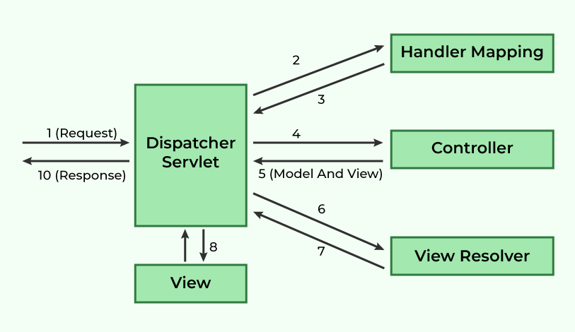
*The only things in this diagram that see with our own eyes is the request and response (postman) and the controller (our Controller Classes). Everything else is under the hood

SpringMVC Application Flow (Verbal)

- When the Tomcat Server receives a HTTP request, it gets passed to the DispatcherServlet (our Front CoC ntroller)
- The DispatcherServlet consults the HandlerMapping (which looks for @RequestMapping annotations) determine which controller to send the request to, based on the /endpoint of the HTTP request.
- The Controller consults the service to process the request
  - (service, dao, and DB do their thing)
- The Controller builds the response, and hands it back to the DispatcherServlet
- The DispatcherServlet then consults the ViewResolver if necessary to process a view (which we won’t use, since we will have our own frontend views)
- The DispatcherServlet hands the response back to the Tomcat Server, which sends it to the front end (or wherever the request came from, maybe postman)
- The HTTP lifecycle starts again whenever a new request is sent!

